Annual Review Report for Students in NCY9 and above

Student’s Views
Please include a Vocational Profile and/or Careers Action Plan if appropriate
What do you want for your future? (My hopes and dreams)
Please consider each of the following (including travel)
- Employment
- Independent Living
- Friends, relationship and community
- Health

Suggested questions:
- What do you need to achieve each of these? E.g. further education, work experience, supported employment
- What can you do to achieve this?
- What help and support do you need?
- What needs to happen?
Have you seen an independent careers advisor?
Yes/No
Does a referral to the Preparing for Adulthood Team (Adult Social Care) need to be made to achieve the identified preparing for adulthood outcomes?
Yes/No/Already completed
What is important to you? (people, hobbies, interests etc)
What has worked well for you? Please consider: 1. Learning and Work, 2. Community and Friends, 3. Being Healthy, 4. Living Independently
What hasn't worked well for you? Please consider: 1. Learning and Work, 2. Community and Friends, 3. Being Healthy, 4. Living Independently
Is there anything that would help to improve things for you? Please consider: 1. Learning 2. Communication 3. Social, Emotional and Wellbeing (your feelings and how you have got on with others) 4. Sensory and/or Physical (mobility and sensory processing, visual skills etc) 5. Self Help, Independence and Keeping Safe
Do you know that you have an EHC Plan?
Yes/No
Has the EHC Plan supported you to make progress over the last 12 months? Suggested questions: How has it helped? What part(s) of the Plan have been helpful or not?
Did you have any help with these answers? If yes please write the name of the person who helped you, their relationship to you and explain how they helped:

Parent/Carer Views

Please note the name of the Parent/Carer who is submitting these views. If there are exceptional circumstances as to why views are not being submitted please note them here.
Relationship to Young Person:
What is working well? (In education and outside of education):
What is not working well? (In education and outside of education):
Parent/Carer hopes for the student now and in the future:
Any other comments the Parent/Carer wishes to make:

Progress and Attainment (Summary)
Progress and Attainment - a summary of the student's Progress and Attainment based on the data uploaded

Include progress towards achieving the identified aspirations and preparing for adulthood outcomes.
Option to upload NEET Risk Identification Tool

If this information is included in another supporting document, please detail here.

Education, Employment and Training Journey
Current course information and level:
Exam Access Arrangements (as assessed):
When were these formally agreed?
Courses previously enrolled on or completed including levels and dates
Next Steps for Education, Employment and Training

Changes to Needs - Educational
Have the student's needs changed as detailed in Section B of the EHC Plan?

Learning and Work (Employment)
Strengths
Needs

Communication and Social Interaction (Community Inclusion)
Strengths
Needs

Being Healthy (Emotional Wellbeing and Sensory/Physical)
Strengths
Needs

Independent Living (Self-Help, Independence Skills and Keeping Safe)
Strengths
Needs

Changes to Needs, Outcomes and Provision – Health
Do you have a diagnosed learning disability? If so, signpost to Annual Health Check. Further information can be found in the guidance document.

Are you submitting a medical report that notes changes to the student's health needs?
Have you got permission from the student's parent(s) or carer(s) to submit a medical report?
Is the student in receipt of Childrens Continuing Care or Adults Continuing Health Care?
If yes, please provide the details
Is the student in receipt of a personal health budget?
If yes, please provide the details of the personal health package

Early Help Assessment Referral
Is there an Early Help Assessment in place?

Changes to Needs, Outcomes and Provision – Social Care
Are you submitting a social care report?
Have you got permission from the student's parent(s) or carer(s) to submit a social care report?
Is the student in receipt of a social care direct payment?
If yes, please provide the details of the direct payment package

Review of Educational Outcomes

Which outcome is being reviewed?: | Overview of progression towards achieving this outcome and any strategies used.: | Has the outcome been met? Use the following scale - 4 = exceeded, 3 = met, 2 = on track, 1 = not on track: | If not met, is the outcome still appropriate?: | If the outcome is not yet achieved, please outline the steps that will be taken to support the child/young person to achieve this outcome: | Is a new outcome required? If so, please specify  Including short and long term  :
Learning and Work
Community and Friends
Being Healthy
Living Independently

Review of Education Provision (Section F)
Has the provision been implemented in Section F? | Impact of the provision in Section F being reviewed | Please state any provisions that are not in place and explain why.  What steps are being taken to implement these provisions | Are there any changes required to the provision in Section F

Personal Budget (including Direct Payments)
Please see guidance for further information on Personal Budgets

Is a personal budget in place?
Is a personal budget being requested at this time?
Is a direct payment being requested to deliver any of the provision in Section F?
If yes, please upload the Personal Budget/Direct Payment Request Form
Is any provision being delivered via a Direct Payment in Education Section F?:
Is any provision being delivered via a Direct Payment in Health Section G?:
Is any provision being delivered via a Direct Payment in Social Care Section H1 or H2?:

Is a review of the Education Direct Payment required?: | Yes/No
Section F
If a review of the Direct Payment is required, what provision is being reviewed in Section F?: | If a review of the Direct Payment is required, what is the recommended change to Section F?: | If a review of the Direct Payment is required, list the evidence provided to support this with regards to Section F.:

Travel to Education Setting
Please see guidance for further information on transport and travel training.
How does the student travel to and from their education setting?:
How can the student travel more independently and what support do they need?:
Through the Annual Review meeting has Travel Training been discussed as an option for the child or young person?:

Contributors to the Review
Contributor Role: | If Other Specify: | Forename | Surname | Invited? | Attended? | Contributed a Report?

Additional Information (Optional)
Action Plan  (eg Request for Advisory Service or ITS update) | Whom  (eg School) | When  (eg 1st April 2025)

Additional Comments

Helpful Resources for Young People, Parents, Carers and Professionals, Preparing for Adulthood – Professional Choices

Scan the QR code or click the link below for helpful resources for Preparing for Adulthood:

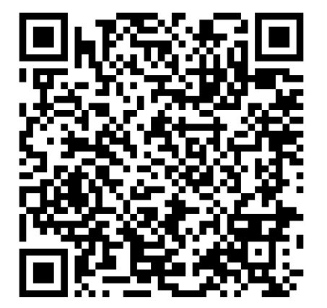

https://professionalchoices.org.uk/helpful-resources-for-young-people-parents-carers-and-professionals/

