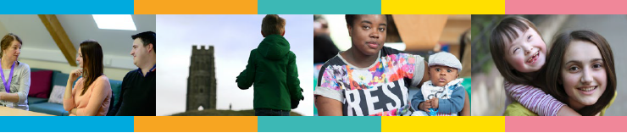

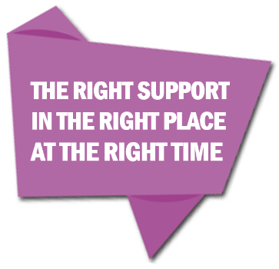**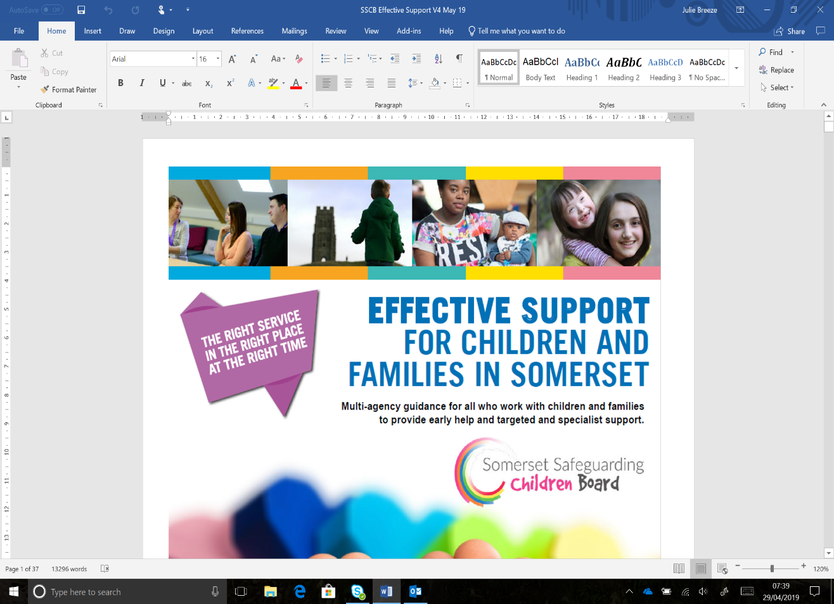Somerset Early Help and Special Educational Needs and Disability (SEND) Support Practitioner Guidance**

* **Early Help Assessment (EHA)**
* **Team Around the Family (TAF)**



Version 2 January 2020

**IF YOU ARE CONCERNED THAT A CHILD MAY BE AT RISK OF, OR MAY BE SUFFERING SIGNIFICANT HARM CALL US ON**

**0300 123 2224**

**If you need further advice on SEND please contact:**

[**LOCAL OFFER**](https://choices.somerset.gov.uk/)

[**www.choices.somerset.gov.uk/**](http://www.choices.somerset.gov.uk/)

**SENDIAS**

Special Educational Needs and Disability (SEND) Information Advice and Support

**01823 355578**

**CONTENTS**

* Introduction 3
* Examples of when you may want to consider 3

completing an EHA

**PROCESS - HOW TO COMPLETE AN EHA**

* Section 1 – Initial details 4
* Section 2 – Person undertaking this assessment 4
* Section 3 – Application for an EHA 4
* Section 4 – Children and young people in this

Family 4

* Section 5 – Adults in this home and adults

who do not live with the child/young person but are important to them 7

* Section 6 – Who is supporting this family now? 7
* Section 7 – Assessment 8
* Section 8 – Summary of need 9
* Section 9 – Requesting support from other   
  organisations 10
* Quick guide to completing an EHA 11

**TEAM AROUND THE FAMILY (TAF) PROCESS**

* Introduction 12
* Preparing for the meeting 13
* Section 10 - TAF details 13
* Section 11 - TAF review meeting notes 13
* Section 12 - Early help action plan 14
* Section 13 - Summary of need 14
* Section 14 - Closing summary 14



**INTRODUCTION**

When a child, young person or family is in need of support it is important to identify the best way forward at the earliest opportunity. The Somerset Early Help Assessment helps children, their family and practitioners working with them to clearly record their current situation, strengths and needs, followed by a plan which will help the family to improve their lives. The EHA belongs to the child/young person and family and they should receive a copy of all relevant documents.

In Somerset we also have a Young Person’s Led EHA, this version has been designed and adapted, involving young people. It should be used where young people have sufficient understanding to give consent/agreement to the assessment and want to take an active part in completing it. We recommend that Section 7 in particular is completed with the young person.  
  
It is good practice to give leaflets to both the child/young person and family about the purpose of an EHA. These leaflets can be found on [Professional Choices](http://professionalchoices.org.uk/download/1018/). It is also good practice that once an EHA is closed, to ask for feedback from the family which is captured and shared.

**This document should be read alongside the Effective Support for Children and Families in Somerset guidance.**

**EXAMPLES OF WHEN YOU MAY WANT TO CONSIDER COMPLETING AN EHA**

This is not an exhaustive list, but gives you examples of things to look out for:

* A child or young person, their parent/carer, or a practitioner raises a concern with you and it is agreed an EHA should be completed. This may help everyone understand the child better.
* When someone in the family or social network is experiencing issues (such as substance abuse/misuse, violence, physical or mental health problems, crime) that might impact on the child.
* When there is a concerning change in a child’s appearance, demeanour or behaviour. This could be due to a significant family event (for example bereavement or family breakdown) or worries at home, such as additional caring responsibilities.
* When a child is repeatedly missing medical appointments and/or immunisations.
* When a child is missing developmental milestones or making slower progress than expected at an early year’s setting, school or college.
* When a child is persistently absent or missing from an early year’s setting, school or college, or has been excluded.
* When a child is experiencing physical or emotional ill health or disability.
* When you have a concern a child /young person may have Special Education Needs.
* When a child is presenting with challenging or aggressive behaviours, abusing/misusing substances or committing offences.
* When a child is being bullied or is a bully themselves.
* When the child is experiencing other disadvantages for reasons such as race, gender, sexuality, religious belief, or disability.
* When a child is homeless, being threatened with eviction, or living in temporary accommodation.
* When a young person is becoming a parent, or if the child has parents who are young.
* When the young person is at risk of not being ready to make the transition to post-16 services, or if they are not in education or employment.
* The child’s or young person’s needs are unclear, broader, or more complicated than your service can address alone.

**PROCESS - HOW TO COMPLETE AN EHA**If you are aware an EHA has been completed, with consent/agreement from the family it is your responsibility to contact the practitioner and request a copy of the EHA. If you have any updates or additional information, this can be identified by using a different colour or font style.

**All items marked with * on the EHA are mandatory for all agencies and must be completed.**

**SECTION 1 – INITIAL DETAILS**

Where there is more than one child or young person, involved in this EHA, the named child or young person should be the one who is the focus of the EHA. If there is no ‘main’ child or young person, record details for the eldest child/young person in the family here.

**SECTION 2 – PERSON UNDERTAKING THIS ASSESSMENT**

Add details of the person completing the EHA. This is required because in most cases this person will become the lead practitioner until the first team around the family (TAF) meeting is held.

If you have completed this EHA as a result of a panel / Team Around the School (TAS) / One Team discussion, please include the name of this panel in the Organisation/Team section.  
  
**SECTION 3 – APPLICATION FOR AN EHA**Complete the first consent/agreement box. This consent/agreement allows the EHA to be shared with other practitioners who may be able to provide support and/or advice.

For an EHA to be effective it should be undertaken with the agreement and involvement of the child/ young person and their parents or carers as well as all the practitioners who are working with them.

It should take account of the child’s wishes and feelings wherever possible, their age, family circumstances and the wider community context in which they are living.  
  
See the section on ‘Consent’ in the [[Effective Support for Children and Families in Somerset guidance](http://www.somerset.gov.uk/sscbthresholds)](http://www.somerset.gov.uk/sscbthresholds)**.**

For information on Parental rights and responsibilities (PR), you can go to [gov.uk](https://www.gov.uk/parental-rights-responsibilities) or refer to [Effective Support for Children and Families in Somerset guidance](http://www.somerset.gov.uk/sscbthresholds) or the SEND Effective Support guidance.

* Full Care Order – Local Authority (LA) has majority PR. Social worker rather than birth parent can give consent for an assessment.
* Interim Care Order - LA has majority PR. Social worker rather than birth parent can give consent for an assessment.
* Emergency Protection Order – Parent retains full PR. They must be asked for their consent to any assessment.
* Placement Order - LA has majority PR. Social worker rather than birth parent can give consent for an assessment.
* Child may be in an adoption placement – please check with adopter whether delegated authority has been given to give consent for this type of assessment.
* Supervision Order - Parent retains full PR. They must be asked for their consent to any assessment.
* Section 20 (accommodated) - Parent retains full PR. They must be asked for their consent to any assessment

Complete the second consent/agreement box if you have identified a Level 4 safeguarding issue.

If you are unsure if you need to gain consent/agreement please seek advice from your Designated Safeguarding Lead who can access the Consultation Line for **Children’s Safeguarding Leads, GP’s and Lead Practitioners on 0300 123 3078.**

**SECTION 4 – CHILDREN AND YOUNG PEOPLE IN THIS FAMILY**

If there are more than three children or young people, please download the additional children and young people form on Professional Choices.

**Child/Young Person 1** **column** - this is the child or young person named in section 1.   
  
**Gender** – Choose from the drop down

Someone’s sex can have an impact on how they are perceived (or think they are perceived) in society, their experiences and their reactions in certain situations. Equally if someone is struggling to identify their sex and where they fit this can affect their reactions and responses. The concept of sex and gender has changed over the last 3 years with some people less likely to identifying as one sex or another. Someone could identify as female or male. They could however identify along a spectrum from female to male experiences over time.  The questions we have included will help us to establish how someone identifies and any potential support that might be needed or available.

Do you consider any of the children/young people young carers? Are they caring for someone in the family with a long-term illness or disability? - This is a simple YES / NO question which, if answered in the affirmative, requires further assessment of the nature and types of care provided, needs and support.

The official definition of a Young Carer is:

**'…a person under 18 who provides or intends to provide care for another person (of any age, except where that care is provided for payment, pursuant to a contract or as voluntary work).' Children and Families Act 2014 Section 96.**

In considering whether the child/young person has a carer role, think about:

* Person for who the caring role relates
* Relationship – for example mum, sibling, grandparent

Are there other people who should be consulted in considering whether a child has a young carer role?

* The young carer
* The young carer's parent(s)
* Any other person who the child or young person or a parent of the child or young person requests the authority to involve

**If the answer to the trigger question is YES, move on to the three screening questions.**

**What caring are they doing?**

A young carer may care for family members who are disabled or chronically ill, or for adults who are misusing alcohol or drugs. Care may be physical, practical or emotional in nature, and can include financial management above the child or young person’s level of maturity.

The assessment (EHA) must consider what other care is available for the care recipient and from who; for example an agency, other family or friends.

If another under 18-year-old child in the home is a carer, their support needs may also require an assessment.

The assessment must consider the nature and frequency of care provided (the care package) and whether this care can be maximised from other (not young carer) resources.

**Types of care to consider:**

* Cleaning / hoovering / dusting
* Washing / drying Up / tidying Kitchen
* Cooking / preparing food
* Washing / drying clothes / ironing
* Shopping for food / household items
* Gardening / outdoor work
* Managing money / bills etc.
* Getting up in the night to help (broken sleep)
* Help with washing and bathing and dressing
* Helping with management of medication
* Organising things e.g. appointments
* Cheering up / calming down – emotional support
* Making sure they are safe when out e.g. road safety
* Helping them with lifting i.e. person, equipment etc.
* Helping to care for a sibling
* Help with walking or moving around the house
* Pushing wheelchair / buggy
* Caring for pets
* Interpreting / sign language

The assessment should consider how any lack of care by the child / young person would impact upon:

* The person being cared for
* The wider family’s ability to maintain the wellbeing of that person

**What are the impacts on the child/young person?**

Assess whether any of the tasks provided by the young carer can be considered inappropriate or excessive based upon the age, sex, ability, wishes and feelings of the young carer (including impact on education, training or employment).

The assessment should identify why tasks undertaken could be considered inappropriate or excessive for that individual child / young person – this could include:

* Being overly physically strenuous
* Being inappropriately personal
* Providing emotional support
* Administering medication or supervising safety regimes
* Responsibility for budgets and financial management
* Impact on own wellbeing including emotional or developmental impacts

**What support do they need?**

Each child / young person with carer responsibilities will have their own, individualised support needs which reflect the individual impact upon the young carer. Areas to be considered will include:

* Health, development and wellbeing
* Relationships including personal and family
* Education, training and employment
* Leisure and activity
* Ambition and goals

Having assessed the support needs, the assessment should lead to an action plan which should be completed at the Team Around the Family Meeting.

**The Young Carer assessment must always be considered in line with safeguarding processes and significant risk escalated through the appropriate agency channels.**

Specifically, the assessor must consider the Effective Support for Children and Families in Somerset guidance. In particular, the assessor must consider whether the Young Carer Assessment suggests that the child/young person should be considered a Child in Need under Section 17 of the Children Act 1989 or require a service at Level 2 or 3 with a lead practitioner approach.

**Does the child/young person have a disability?** – The law says that you are disabled if;

* It is very hard for you to do normal everyday things because of your disability; and
* You have found these things hard for a long time; at least one year.

In Somerset we believe that the basic needs for disabled children/young people are no different from those of any other child/young person. But we recognise that some disabled children/young people have additional needs or face additional barriers which inhibit and prevent their inclusion in society.

**Does the child/young person have a Special Educational Need (SEN)? –** Children and young people with SEN may need extra help because of a range of needs. Paragraphs [6.27 – 6.35 of the 0-25 SEND Code of Practice](https://www.gov.uk/government/uploads/system/uploads/attachment_data/file/398815/SEND_Code_of_Practice_January_2015.pdf) sets out four areas of SEN.

A child or young person who has Special Educational Needs (SEN) may;

* Find it harder to learn than other people of their age
* Face challenges that make it hard to go to school or college
* Need extra or different support to learn

**SECTION 5 – ADULTS IN THIS HOME AND ADULTS WHO DO NOT LIVE WITH THE CHILD/YOUNG PERSON BUT ARE IMPORTANT TO THEM**

If there are more than three adults, please download the Additional Adults Form on Professional Choices.

Please record details for all adults who live in the family home and details of any adults who are important to the child, such as those who play a part in their lives, who live elsewhere. Examples would be an absent father, grandparents, a neighbour, aunts and uncles.

**SECTION 6 – WHO IS SUPPORTING THIS FAMILY NOW?**  
It is important to build up a picture of what support is already being offered to the family. If you are aware of who is supporting the family now, please provide their details and what support they are offering.

Please also include details relating to historical support including names, dates and outcomes.



**SECTION 7 – ASSESSMENT**

**Why are you completing this assessment, what concerns do you have?**

**Please refer to the** [**services included in the EHA**](http://professionalchoices.org.uk/children-young-peoples-services/childrens-autism-outreach-team/) **section on Professional Choices, as there may be additional information required for specific services.**

It is essential that the child/young person’s and adults voice is heard within this EHA. This section is where you can record their thoughts, feelings and wishes in relation to what is working well, what are they worried about and what needs to change.

Think about any further information that could help you understand the family’s strengths and needs better. The following may also be a helpful guide of things you may want to think about within this:

* Are the parent(s) able to provide basic care enduring safety and protection?
* Are the parent(s) able to provide emotional warmth and stability? **-** Ask yourself questions such as whether there are consistent displays of emotional warmth, is an interest shown in the child and their development (for example through play or other engagement), is there a tendency to be over anxious or over protective?
* Are the parent(s) able to provide guidance and boundaries?
* Where do they live? –say a little about the neighbourhood where they live. Does this make the family isolated or does it offer good opportunities? What local resources are available to them? Is there a high level of deprivation or anti-social behaviour? What is the impact of this on the child who is the subject of the EHA?
* What do they do (employment/interests)?-Are parents or carers in work and if so what do they do? Have current employment circumstances led to financial issues for the family? Do the family have significant hobbies or interests? What is the impact of this on the child who is the subject of the EHA?
* What support networks do they have? –Describe the support available from the wider family and local community. Are there particular strong friendships or religious or cultural networks? What is the impact of this on the child who is the subject of the EHA
* Are there any current or historical known risks within the family?
* Are there any cultural issues such as religion not already covered?
* What has been tried already and hasn’t worked? What support do the family think they need?
* Can services, family or the community, already involved with the family meet the needs you have identified? If not who else needs to be involved? What do you expect them to do and how will they be able to measure if they have achieved a successful outcome for the child?
* If the needs you have identified are not met, what are you worried will happen to this child? Think about whether the child will be safe if the situation remains the same as you assess at the end of the EHA. Will their basic needs be met? For example, is there suitable accommodation, appropriate food, clothing and sufficient physical and emotional care, to meet developmental milestones?

**How does the parent describe their relationship with this adult?** - The link within the EHA will take to you to the Dorset Hub who are managing face to face referrals for parents/carers in Somerset, who are struggling with their relationships. This page will give you helpful information on support for families in conflict and a request for support form (Referral Stage Questionnaire (RSQs).

Refer back to the [Effective Support for Children and Families in Somerset guidance](http://www.somerset.gov.uk/sscbthresholds) or the SEND Effective Support guidance.   
  
**What indicator of need do you feel this family has met?** - After looking at the Effective Support guidance or the SEND Effective Support guidance, record the current indicator of need for this child/young person and their family using the drop-down box.

**Reason for your judgement** - Using the [Effective Support for Children and Families in Somerset guidance or the SEND Effective Support guidance](http://www.somerset.gov.uk/sscbthresholds) and referring to the indicators of need tables give reasons for your judgement.

**Expected time, date and venue of the first Team around the Family (TAF) meeting** – See page 12 onwards of this guidance for more information regarding this process.

**SECTION 8 – SUMMARY OF NEED**

It is important to be able to record all presenting needs for both reporting and commissioning purposes. This helps Commissioners determine what services are required. If you tick a presenting need ensure they are referenced within the EHA.

There are additional screening tools that can help with the identification of some needs. If you identify that the child/young person is at risk of any of the following, then complete and attach to the EHA:

* Child Exploitation (CE) [CE Screening Tool](http://sscb.safeguardingsomerset.org.uk/protocols-procedures-and-reviews/cse-protocols/)
* Domestic Abuse [ACPO DASH Risk Assessment](http://www.somersetsurvivors.org.uk/how-to-make-a-referral/) or
* The Family Strengths & Needs Toolkit [The Family Strengths & Needs Toolkit](https://sscb.safeguardingsomerset.org.uk/download/7073/)

It is recommended that you summarise these needs in section 7 of the EHA.

You may also find it helpful to complete a Strengths and Difficulties Questionnaire (SDQ) with the child or young person.

**SECTION 9 – REQUESTING SUPPORT FROM OTHER ORGANISATIONS**

**Is this a ‘step up’ or ‘step down’ request?** – In Somerset we have a [Step Up Step Down Protocol](http://www.sscb.safeguardingsomerset.org.uk/wp-content/uploads/2016/02/Step-Up-Step-Down-2016.pdf)

The term ‘Step Up’ and ‘Step Down’ is commonly used to describe children moving between levels of need and is used to describe the process by which a child’s needs change.

This requires all professionals working with children; young people and their families to be familiar with the approach so that if and when a child’s needs change due to a reduced or increased level of need, that these children do not fall between services. Instead, children are held safely in the transition from one service or step to another while maintaining a strong emphasis on a strengths-based approach to working with families to help them identify solutions as to the challenges and problems they face.

If you have identified needs after completing sections 1-8 of the EHA, that require support from an additional service, please select the service from the drop-down box to indicate which agency you would like to request involvement from, see Professional Choices for an explanation of these services. The email address will appear following your selection. It is your responsibility to send the EHA to each service, by copying and pasting the address into an email. See below for example;

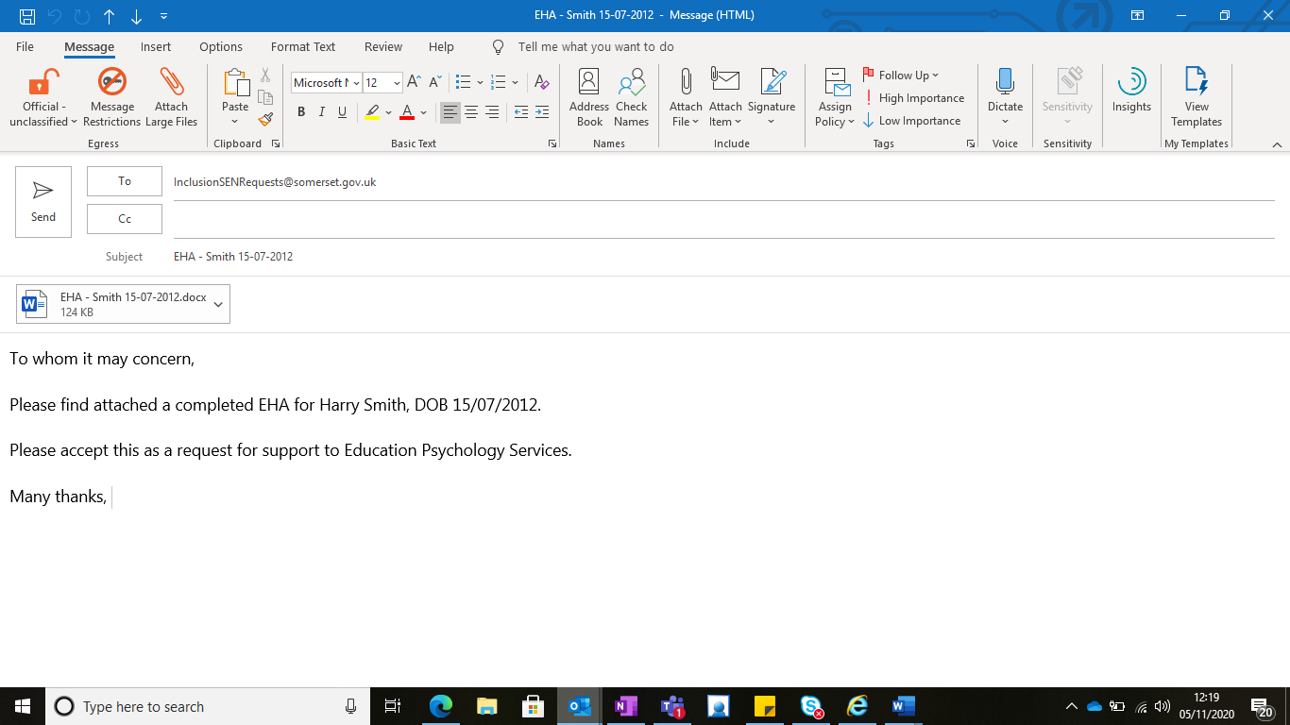

**Quick Guide to the Completion of an Early Help Assessment (EHA)**

Download either an EHA or Young Person’s Led EHA (YP EHA) from Professional Choices

**You are concerned that the child may be at risk of, or maybe suffering significant harm**

No

Yes

Identification of need

Yes

Is the child/young person at immediate risk of harm

Please complete sections **1 to 8.** If you have identified needs after completing these sections, that require support from an additional service, please complete section 9.

You will need to send the EHA to the service you are requesting support from, copy and paste the email address that appears following your selection of service in section 9 of the EHA.

For more support or advice with completing an EHA please contact the **Early Help Advice Line 01823 355803.**

No

Call **Somerset Direct 0300 123 2224** and share your concerns

Please complete the following sections **1 to 8,** and in **section 9,** in the drop-down boxselect

Children’s Social Care Level 4 – SDInputters@somerset.gov.uk

If you are still unsure if the level of need is level 4 and you are a Designated Safeguarding Lead or GP, you can call the **Children’s** **Safeguarding Lead’s** **Consultation Line 0300 123 3078**

**Application for an EHA**  
**Whilst it is best practice to obtain parental consent, if you have assessed that it would place the child[ren]/young person at risk   
of significant harm by sharing your concerns, you do not need to obtain consent when referring to Children Social Care.**By Law, the Early Help Advice Hub are unable to share the EHA if **Section 3** is not completed.

**INTRODUCTION TO THE TEAM AROUND THE FAMILY (TAF) PROCESS**The Team around the family (TAF) meeting brings together a range of different practitioners and the family following the completion of the EHA. The purpose is to bring people together, often with specialist knowledge or expertise, to work out how best to work together to help support a family and to identify the Lead Practitioner. The family should attend too and where appropriate the child/young person. It is important to engage with them throughout the process

Please add additional information/updates to the TAF notes at each TAF meeting - this becomes a rolling document that you can add information to. Use a different colour or font style at each review meeting so it is clear to everyone which information relates to the relevant review meeting. This document belongs to the child/young person and family and they should receive a copy.

**Please do not make a request for involvement to another service using the TAF notes, please update the EHA, including the reason why you are making the request (Section 7) and use Section 9 to identify which service the child/young person and family required.**

Remember – this is a voluntary process – you cannot force the family to attend or take part.

**Team Around the Family (TAF) Process**

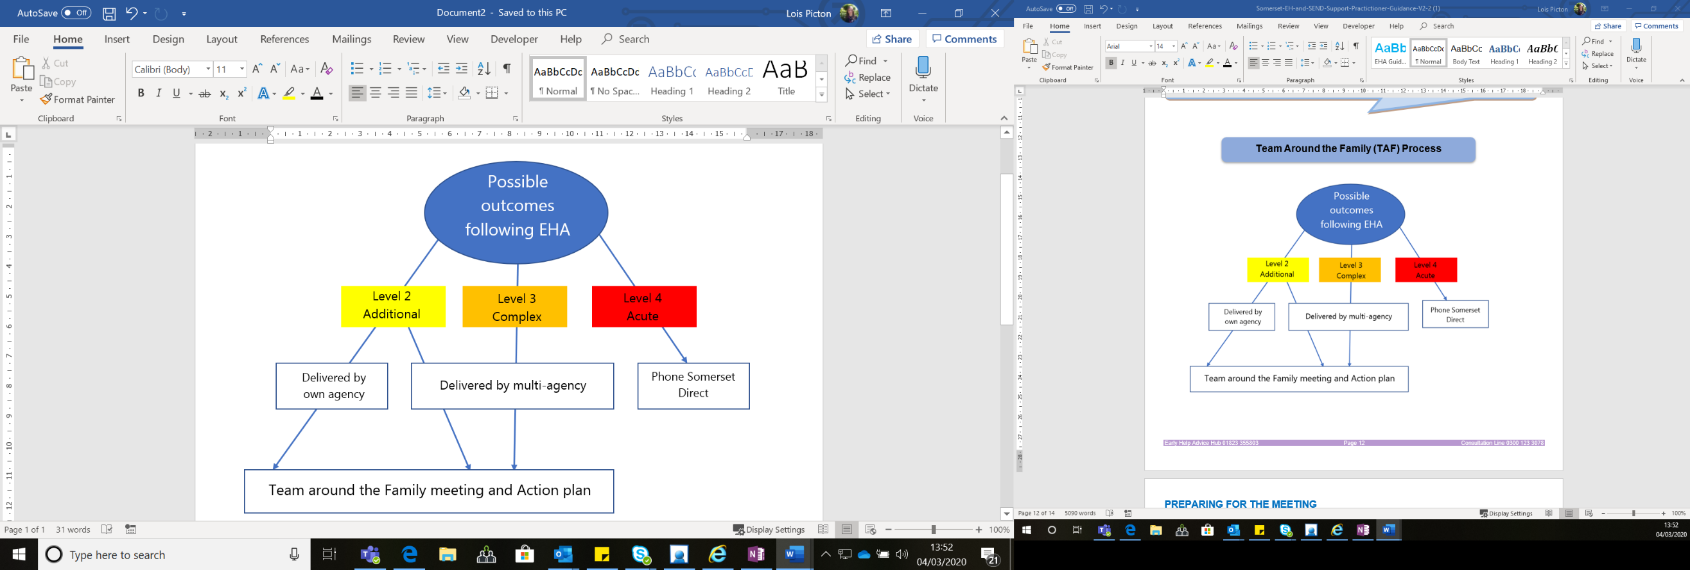

**PREPARING FOR THE MEETING**

* Talk to the family about which practitioners should attend, who is already involved and who should be involved
* Agree with the family who in the family will be included in the meeting
* Think about any communication needs in the family and how you might meet them
* Think about any needs, minority ethnic families or families with Special Educational Needs or disabilities (SEND) or other additional needs children/young people might have
* What help, and support you might need as the person chairing the meeting
* Identify a meeting place, date and time
* Request a Virtual Meeting Room and issue the invites, you must be registered to Professional Choices to use a virtual Meeting Room. Please refer to the Virtual Meeting Room Guides (at [www.professionalchoices.org.uk](http://www.professionalchoices.org.uk))
* Plan the agenda
* Hold the TAF meeting
* Agree the actions and record them on the Early Help Action Plan (Section 12 of the EHA). You can also save this in the virtual meeting room on Professional Choices for colleagues to view.
* Remember to give the family a hard copy.

If a practitioner from another agency cannot attend a meeting, it is important to give them a copy of the EHA and find out prior to the meeting, what support they can offer the family; this can then be discussed at the meeting. Everyone who attends the TAF should take responsibility for delivering their part of the agreed actions.

**SECTION 10 - TEAM AROUND THE FAMILY (TAF) DETAILS**

Use a different colour or font style at each review meeting so it is clear to everyone which information relates to the relevant review meeting. **Date of meeting** – this is the date of the TAF meeting. This allows you to note ongoing TAF meeting dates as this is a rolling document.  **Name of child/young person** – please record the details of all the children/young people the TAF meeting is in relation to.  
**Lead Practitioner** - please add details of the person completing the TAF.   
**Name of attendees** – please include details of who attended each meeting, including the family and child/young person.

**SECTION 11 - TEAM AROUND THE FAMILY (TAF) REVIEW MEETING NOTES**In this section, please detail any significant events. This could include any changes to the family structure, who’s moved in or out, any family bereavements, new siblings or changes in circumstances (housing, employment, finances, health for any family member).  
  
Describe what has worked well (for example, what has been achieved), what are we worried about (for example, what has not been achieved, any new concerns) and what needs to happen, this section should be in the Early Help Action Plan (section 12).

Refer back to the [Effective Support for Children and Families in Somerset guidance](http://www.somerset.gov.uk/sscbthresholds) or the SEND Effective Support guidance and record the current level of need for this child/young person and their family using the drop-down.

Using the [Effective Support for Children and Families in Somerset guidance](http://www.somerset.gov.uk/sscbthresholds) or the SEND Effective Support guidance give reasons for your judgement.

**SECTION 12 - EARLY HELP ACTION PLAN**

* Record the date when the TAF meeting took place using the drop-down list
* Ensure you refer back to Section 7 of the EHA and agree actions for any concerns/worries that are identified
* Actions needs to be clear, realistic and achievable
* Only use actions that contribute to making the changes
* It is important that the person who is named to complete the action is aware of the action and is in agreement with it
* Record the date the actions need to be reviewed and completed using the drop-down list
* If you have to use acronyms or jargon, explain them in full.

It is recommended that you meet regularly (6-8 weeks) for TAF meetings, to review and monitor the child/young person’s and family’s needs. At the end of each TAF meeting set a date for the next review meeting and record this date using the drop-down list.

It may be helpful to look at the [Somerset Core Standards for SEND](https://choices.somerset.gov.uk/025/education/what-to-expect-from-education/).

**SECTION 13 - SUMMARY OF NEED**   
If you tick a need that you have identified, please ensure these needs are referenced within the EHA or TAF.

**SECTION 14 – CLOSING SUMMARY**   
To officially close the EHA, you should do this at a TAF meeting if possible, by completing this section. The EHA and TAF notes should be stored according to your organisation’s policy. If you are not able to close at a TAF meeting, then complete this section and inform the family and practitioners involved you have done this.

Use the drop-down options to select why has the EHA/TAF process has been closed. Please consider the following

* **If you are requesting a step-up** record which Level 3 or 4 service the concerns have been stepped up to, the date the step up was accepted and the name of the allocated worker in that organisation.
* **If the family are moving to a new area** - record if the family consent/agree to a new area being contacted, their new address and if consent/agreement is given, who you contacted in the new area and the date the EHA was sent to them.
* **If the family withdraw consent/disengage** - If you assess that disengagement increases risk to the child/young person, please speak to your Designated Safeguarding Lead (DSL) or if you are the DSL or a GP you can contact the Consultation Line on 0300 123 3078 to discuss this further.

Refer back to the [Effective Support for Children and Families in Somerset guidance](http://www.somerset.gov.uk/sscbthresholds) or the SEND Effective Support guidance and record the level of need for this child/young person and their family using the drop-down at closure and give reasons for your judgement. Please consider has the level of need changed (reduced or increased) from your TAF meeting? If so why?

See [virtual meeting room guidance](http://www.professionalchoices.org.uk/) in the help section on Professional Choices for how to close any associated virtual meeting rooms.